STATE OF ALASKA
COASTAL IMPACT ASSISTANCE PROGRAM

BUDGET NARRATIVE ATTACHMENT

Your Budget narrative should provide a complete picture of the project so that the Bureau of Ocean Energy Management, Regulation, and Enforcement (BOEMRE, formerly MMS) is confident that you have considered all project needs and that the project is likely to succeed. BOEMRE requires a complete breakdown of how you will spend the project funds and how you calculated your estimated costs. The attached template provides guidance as to the level of detail BOEMRE needs to process your grant application.

To avoid delays in funding, you are encouraged to work with your agency’s financial personnel to ensure compliance with your agency’s accounting practices.

GENERAL DIRECTIONS:
- The Budget Narrative must support the tasks described in the Project Narrative. Items noted in one document must be reflected in the other (e.g. if you are showing costs for travel, your project narrative should discuss travel).

- Identify all costs for each task described in the Project Narrative, even if they are not being funded through CIAP. Be clear as to what will be funded by CIAP and what will not be funded by CIAP. Identify the source of other funds including donated time or equipment (e.g. if your agency is contributing staff time to the project, note so). Although there may be no cost to the grant, it helps provide a complete picture of how the project will be accomplished.

- BOEMRE is required to determine that costs are reasonable. For each cost category indicate how you determined the cost (e.g., estimated contractual hours and wages are based on cost of similar services contracted for similar projects; cost of equipment X was based on quotes from store Y).

- Retain document formatting as much as possible.

- Save the document in Word 97-2003 (BOEMRE cannot read Word 2007).

- Directions within the template are in BLUE. Delete the directions after addressing them.

- Excel Tables have been inserted into the document:

- You are encouraged to use the tables to the extent they work for your project, but are not required to use them.

- To activate, double-click on the table. This will open an active Excel window that you can change as needed.

- The formulas and headings provided in the tables are to give you guidance and help with consistency in the Budget Narrative. Modify them as needed to best represent your project.

- Examples on how to complete the tables are in RED. Replace the examples with the information from your project.

- Carry numbers to two decimal places. Do not round the totals.
STATE OF ALASKA
COASTAL IMPACT ASSISTANCE PROGRAM

BUDGET NARRATIVE ATTACHMENT

- Project Title: Use same title as provided on Project Narrative

- General Notes to BOEMRE
- The Alaska Department of Natural Resources (DNR), Division of Coastal and Ocean Management (DCOM) is the designated state agency for CIAP. DCOM will use a reimbursable services agreement (RSA) to the state agency conducting the project (as listed on the Project Narrative).
- The RSA will include language requiring compliance with 2 CFR 225, and in particular clarifying that all costs must be fair and reasonable. Each sub recipient will ensure that all cost principles are met for all contracts entered into.
- The project proponent will follow state procurement rules for all purchases and contracts.
- Pre-award costs reflect actual costs.
- Post award costs are estimates. However, only actual costs will be charged to this grant.

- Project Budget Narrative
- Spending Categories by Major Task

- Salaries and Wages
Estimate number of hours, and the hourly rate of compensation proposed for each employee by task. Indicate if you have averaged in scheduled or anticipated pay raises.
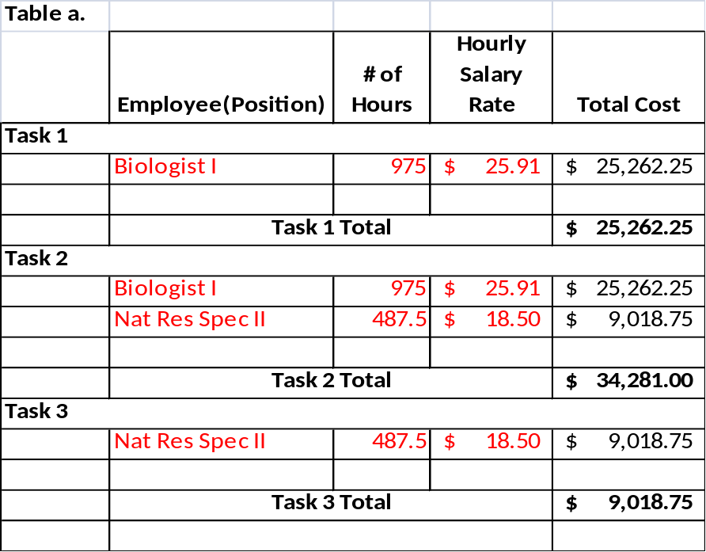

- Fringe Benefits
Indicate the hourly fringe benefit rates for each task. Explain what costs are covered in this category (e.g. health insurance, annual leave, etc).

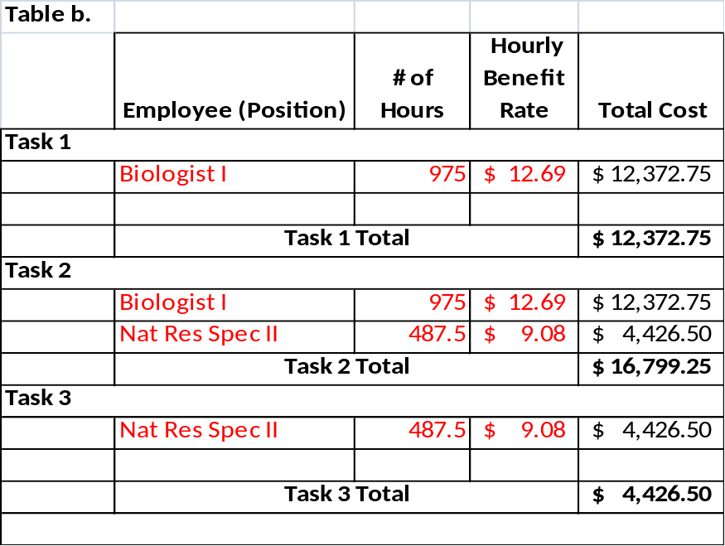

- Travel
State the purpose of the trip and itemize the estimated travel costs by task to show: the number of trips required; the destinations; the number of people traveling; the per diem rates; the cost of transportation; and any miscellaneous expenses for each trip. Calculations of other special transportation costs (such as charges for use of applicant-owned vehicles or vehicle rental costs) should also be shown. Only include employee travel. Show travel by contractors under Contractual (cost category f.).

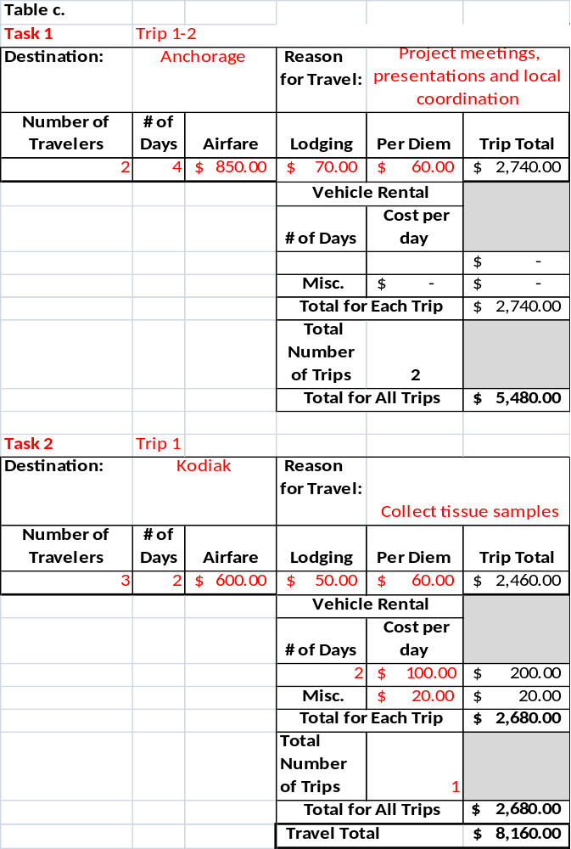

- Equipment
Show the cost of all special-purpose equipment you will purchase. "Special-purpose equipment" means equipment having a useful life of more than 1 year and having an acquisition cost of $5,000 or more per item. Each item should be itemized and include a full justification. Describe the equipment in sufficient detail that a layperson would have a basic understanding of the equipment (e.g., size, special transportation, deployment, or energy needs, etc.). Your agency will retain any equipment purchased. However, indicate what will happen to the equipment once the project is complete. If you intend to sell the equipment, you must give the proceeds to BOEMRE. Discuss any transportation, installation, or other needs associated with the equipment, and whether those costs are included in the price of the equipment or included elsewhere. Indicate how you determined the estimated costs.

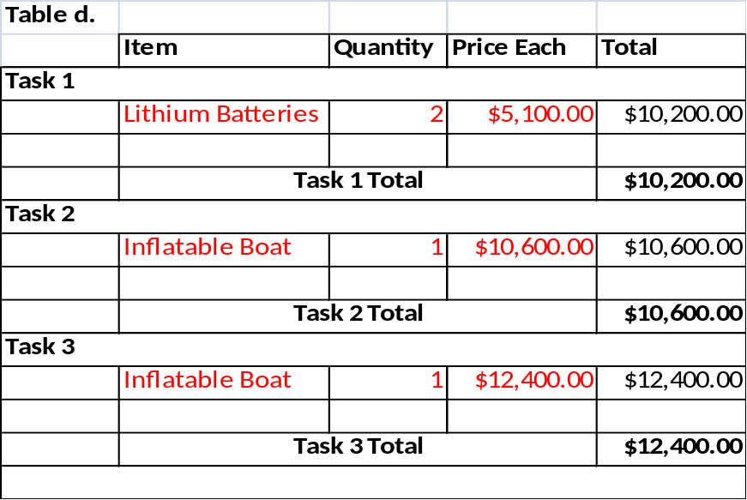

- Supplies
Enter the cost for all tangible property. Include the cost of office, laboratory, computing, and other supplies separately. Provide detail on any specific item that represents a significant portion of the proposed amount.
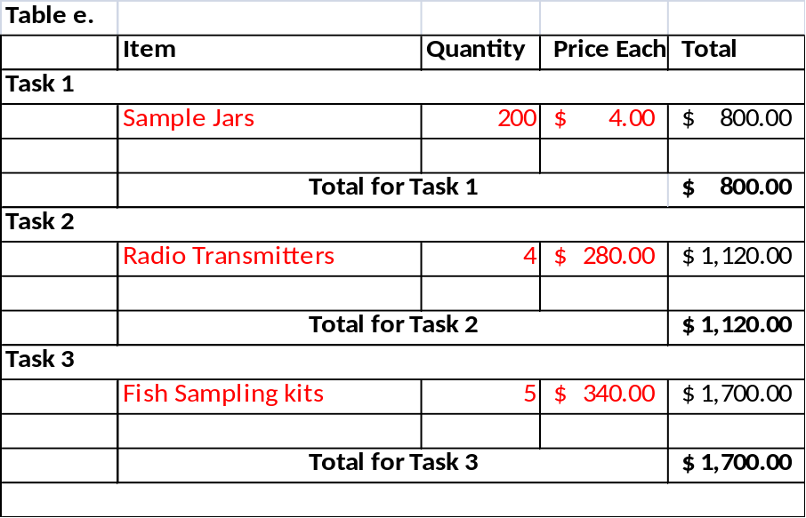

- Contractual Services or Consultants
Identify contractual services or consultants by task. Provide the estimated amount of time required, and estimated rate per day or hour. Within the contractual table, separate out personnel costs, travel costs, and other costs associated with a contract.

List the contemplated contractors by name, if known. If known, state whether the consultants' rate is the same as they would have received for similar services under Government contracts or assistance awards.

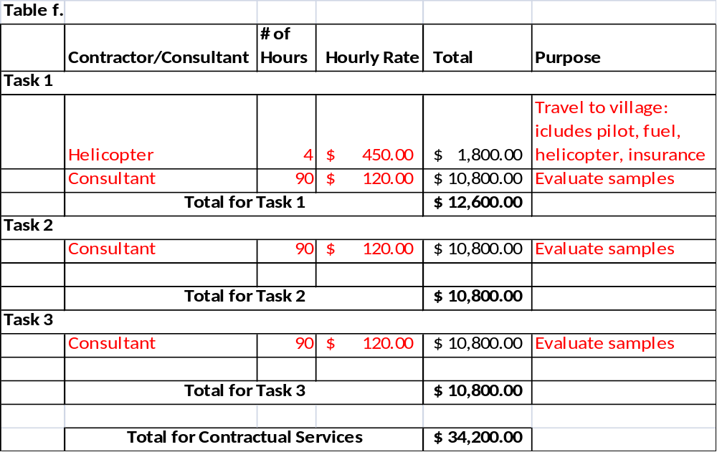

- Construction
For non-construction projects with a construction component, provide the cost of the construction component. Describe how the figure was obtained (the process for obtaining the bid price) and how the total cost was determined reasonable.

- Other Direct Costs
Itemize the different types of costs not included elsewhere, such as rental of equipment, publication costs, or other services. Provide breakdowns showing how the costs were estimated; for example, computer time should show the type of computer, estimated time of use, and the established rates.

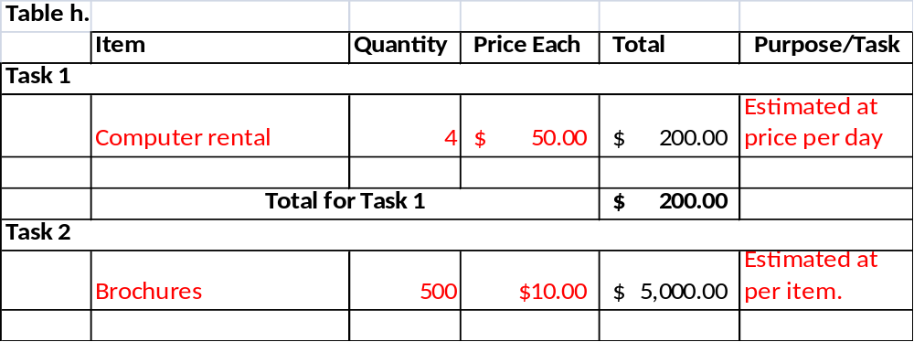

- Budget by Task
Provide the following budget for each major task.

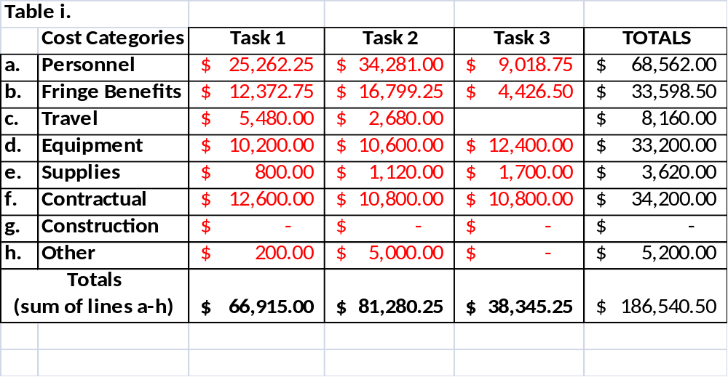

- Indirect Cost/General and Administrative (G&A) Cost (FY 2007 and 2008 grant):
Show the indirect rate, cost base, and amount for allowable indirect costs per task. A copy of the indirect negotiated cost agreement with the Federal government must be included. If a rate is not established, the recipient must follow the procedures located at: http://rates.psc.gov/fms/dca/s&l.html. You may not charge an indirect rate that is higher than your federally approved rate.

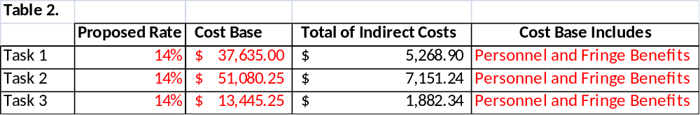

- Income:

If applicable (e.g. income generated by the sale of maps), describe the source of program income and how the income will be used. Income generated with CIAP funds must be put back into the project.

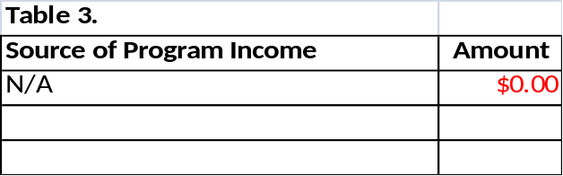

- Incurred Costs Before Grant Award :
Include a complete cost breakdown for costs you will incur before the grant is awarded. Use actual costs rather than estimates. Indicate the actual date the project started, incorporating any time before the award is granted. Be sure to include these numbers in the budget described above.

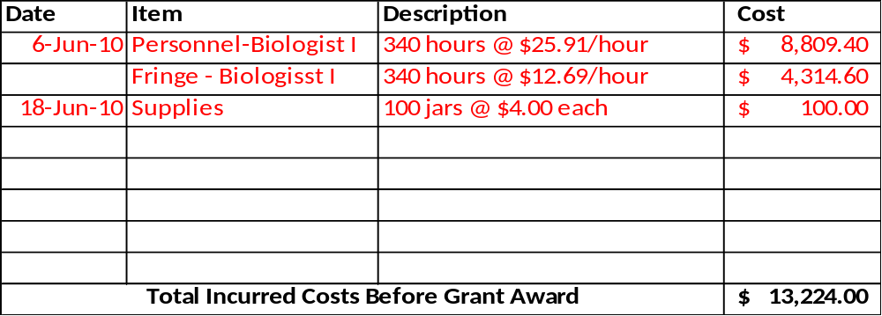

STATE OF ALASKA
COASTAL IMPACT ASSISTANCE PROGRAM

SUMMARY BUDGET

Project Title: Use same title as provided on Project Narrative

Budget Categories
Fill in table below with costs of each item to be completed with CIAP funds through this grant. The information must reflect the information in the Budget Narrative. DCOM will use this information to complete the forms on grants.gov.

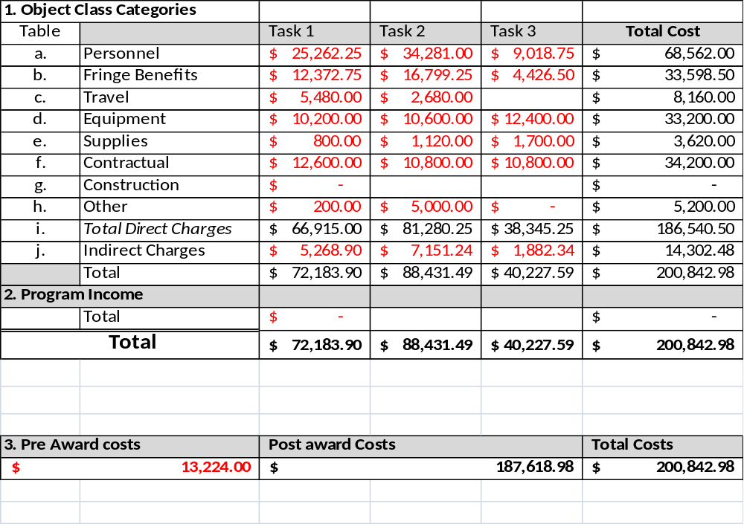
Forecasted Cash Needs:
Fill in the table below estimating your funding needs by quarter. Be aware that BOEMRE will cap drawdowns at the estimated quarterly expenses. However, BOEMRE does allow you to carry funds over from one quarter to the next. DCOM recommends you consider this in your estimates. The “first year” starts when the grant is awarded. Quarters and subsequent years are calculated based on the grant award. Include all pre-award costs in the first quarter.



